SHIRLEY TEMPLE BLACK

Shirley Temple Black is a retired politician. She lives with her husband in California. She likes cooking and playing with her grandchildren. Also, she sometimes works at Stanford University for the Institute of International Studies. She goes there every month and meets foreign ministers. They discuss world problems.

THE CHILD STAR
When she was very young, Shirley was a famous movie star. She started in films when she was only three years old! She could act, she was a good singer and she also danced well. She liked acting very much, and worked in over 50 films. But when she was 20, she retired from the cinema.

WHY DID SHE STOP ACTING?
From the age of three Shirley worked very hard for 20th Century Fox.
„I acted in three or four movies every year. Fortunately I liked acting!“ And the public loved her and her films. The films earned over $35 million.
She says, „I didn‘t go to school. I studied at the studio and my mother looked after me there.“
So why did she stop acting? When she was 12 she finally started school. She was a good student and she wanted to go to university. She was still a good actor, but her films weren’t so popular, because she wasn’t a little girl any more. She decided to change her career. It was a big change – from actor to politician. She says, „I was a politician for 35 years, but people only remember my movies!“

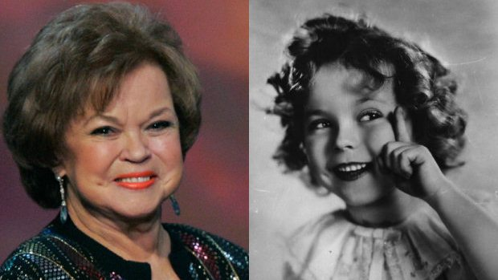

SHIRLEY TEMPLE BLACK – poslechové cvičení

A. Doplňte slovesa, která slyšíte.

Shirley Temple Black ______________ a retired politician. She ______________ with her husband in California. She ______________ cooking and ______________ with her grandchildren. Also, she sometimes ______________ at Stanford University for the Institute of International Studies. She ______________ there every month and ______________ foreign ministers. They ______________ world problems.

B. Doplňte slova z rámečku (podle poslechu).

could | acting | movie | retired | worked | singer | started | young | only | danced

THE CHILD STAR
When she was very ______________, Shirley was a famous ______________ star. She ______________ in films when she was ______________ three years old! She ______________ act, she was a good ______________ and she also ______________ well. She liked ______________ very much, and ______________ in over 50 films. But when she was 20, she ______________ from the cinema.

C. Doplňte slova z rámečku (podle poslechu).

decided | liked | earned | wasn‘t | looked | change | acted | remember
studied | wanted | acting | worked | still | started | politician | loved

WHY DID SHE STOP ACTING?
From the age of three Shirley ______________ very hard for 20th Century Fox.
„I ______________ in three or four movies every year. Fortunately I ______________ acting!“ And the public ______________ her and her films. The films ______________ over $35 million.
She says, „I didn‘t go to school. I ______________ at the studio and my mother ______________ after me there.“
So why did she stop ______________? When she was 12 she finally ______________ school. She was a good student and she ______________ to go to university. She was ______________ a good actor, but her films weren’t so popular, because she ______________ a little girl any more. She ______________ to ______________ her career. It was a big change – from actor to politician. She says, „I was a ______________ for 35 years, but people only ______________ my movies!“

