Přečtěte si článek a poté rozhodněte, zda níže uvedené věty jsou pravdivé (připiš P) či nepravdivé (připiš N).

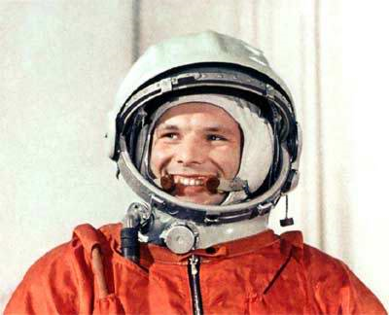
YURI GAGARIN (1934 – 1968)

The first man in space

Yuri was born on a farm and his family was very poor. As a teenager in World War II, he saw his first plane – a Russian fighter jet. At that moment, he knew that he wanted to be a pilot. He studied hard so that he could join a flying club. His teachers thought he was a natural pilot and told him to join the Russian Air Force.
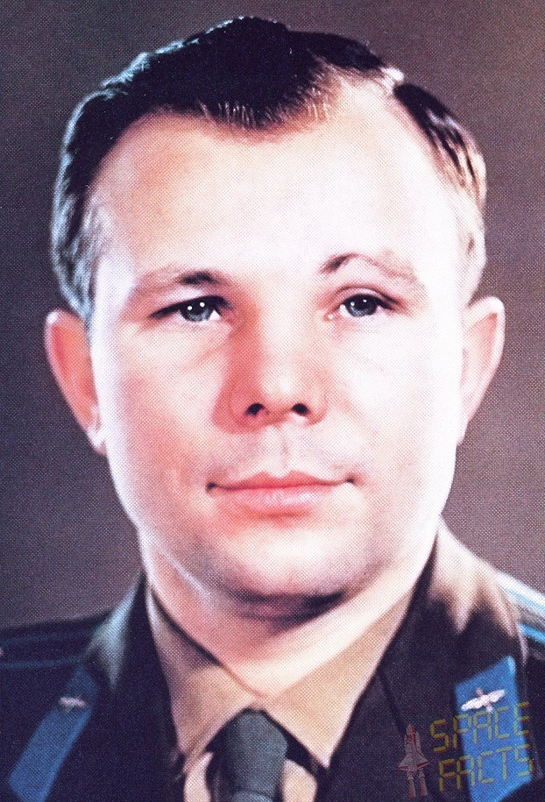
He became an excellent pilot. And he was now a husband and father. But when the first Russian satellite went into space, he wanted to become an astronaut. After two years of secret training, the doctors chose Yuri because he was the best in all tests. On 12th April 1961, when he was 27, he finally went into space. It was very dangerous, because the doctors didn´t know if Yuri could survive the journey. When he came back to Earth he was famous, and he travelled around the world to talk about his experiences.
He wanted to go into space again, so in 1967 he began training for the next space flight. he was also a test pilot for new Air Force aeroplanes. But the next year he died when his fighter jet crashed on a test flight. He was only 34.

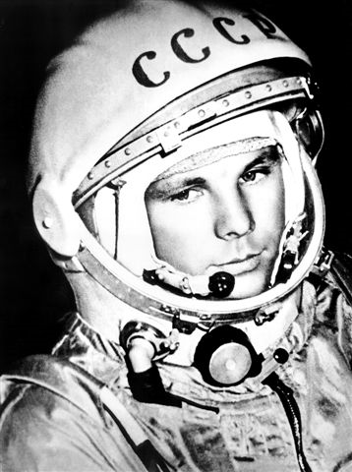
__________ Yuri came from a rich family.
__________ He had a short but exciting life.
__________ He fought in a World War.
__________ He wanted to be a pilot when he was a child.
__________ He was a very good student.
__________ He flew fighter jets.
__________ He was married, but didn´t have any children.
__________ He went into orbit in the first Russian satellite
__________ He travelled to Europe to talk about his experiences.
__________ He died in a plane crash.

Minislovníček:

poor = chudý join = vstoupit, připojit se air force = vzdušné síly, letectvo
survive = přežít experience = zkušenost, zážitek the best = nejplepší
journey = cesta flight = let fighter jet = proudová stíhačka
orbit = oběžná dráha

