Přečtěte si článek a poté rozhodněte, zda níže uvedené věty jsou pravdivé (připiš P) či nepravdivé (připiš N).

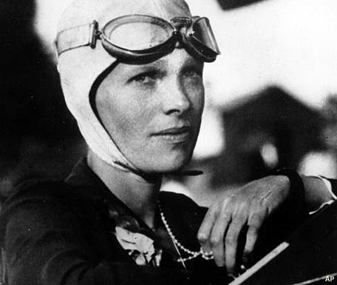
AMELIA MARY EARHART (1897 – 1937)

The first woman to fly across the Atlantic

Amelia was born in her grandparents‘ house in Kansas. Her parents didn´t have any money, but her grandparents were rich and sent her to the best schools. At the age of twenty she decided to study nursing and worked in a hospital in World War I. When she was 23, she visited an airshow and went up in a plane. At that moment, she knew that she wanted to be a pilot.
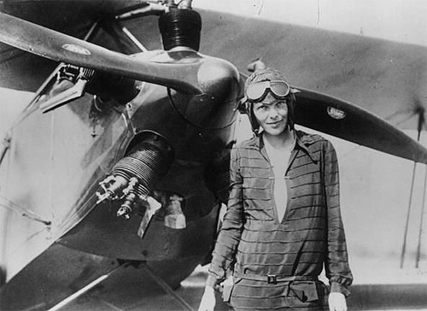
In 1920 flying was dangerous and people didn´t think it was the activity for women. But Amelia had flying lessons, and a year later, she broke her first record – she flew up to 14,000 feet. She married at 34, but never had children. The next year she became the first woman (and the second person) to fly alone across the Atlantic. She was now famous, and she travelled around the world to talk about her experiences. And in 1935, when she was 38, she became the first person to fly alone across the Pacific.
When she was nearly 40, Amelia wanted to be the first woman to fly around the world. She began the 29,000 mile flight in Miami on 1st June 1937. On 2nd July she was nearly at the end of her journey, when she and her plane disappeared near Howland Island in the Pacific Ocean.
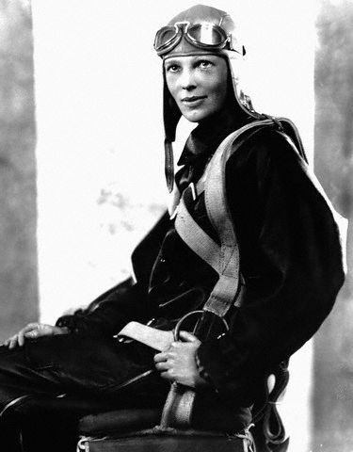
__________ She came from a rich family.
__________ She had a short but exciting life.
__________ She fought in a World War.
__________ She wanted to be a pilot when she was a child.
__________ She broke her first record in 1920.
__________ She was the first person to fly alone across the Pacific.
__________ She flew fighter jets.
__________ She was married, but didn´t have any children.
__________ She travelled to Europe to talk about her experiences.
__________ She died in the Pacific.

Minislovníček:

decide = rozhodnout se flight = let nurse = zdravotní sestra
experience = zkušenost, zážitek jet = proudová stíhačka journey = cesta

