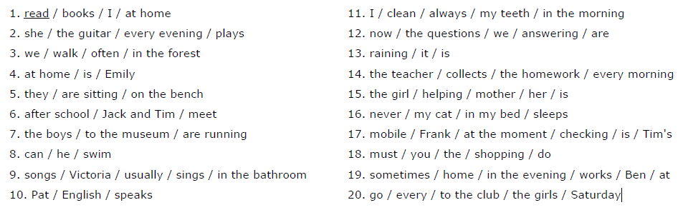
Sestavte věty. Name: _______________________

1. ______________________________________________________________________________________
2. ______________________________________________________________________________________
3. ______________________________________________________________________________________
4. ______________________________________________________________________________________
5. ______________________________________________________________________________________
6. ______________________________________________________________________________________
7. ______________________________________________________________________________________
8. ______________________________________________________________________________________
9. ______________________________________________________________________________________
10. ______________________________________________________________________________________
11. ______________________________________________________________________________________
12. ______________________________________________________________________________________
13. ______________________________________________________________________________________
14. ______________________________________________________________________________________
15. ______________________________________________________________________________________
16. ______________________________________________________________________________________
17. ______________________________________________________________________________________
18. ______________________________________________________________________________________
19. ______________________________________________________________________________________
20. ______________________________________________________________________________________

