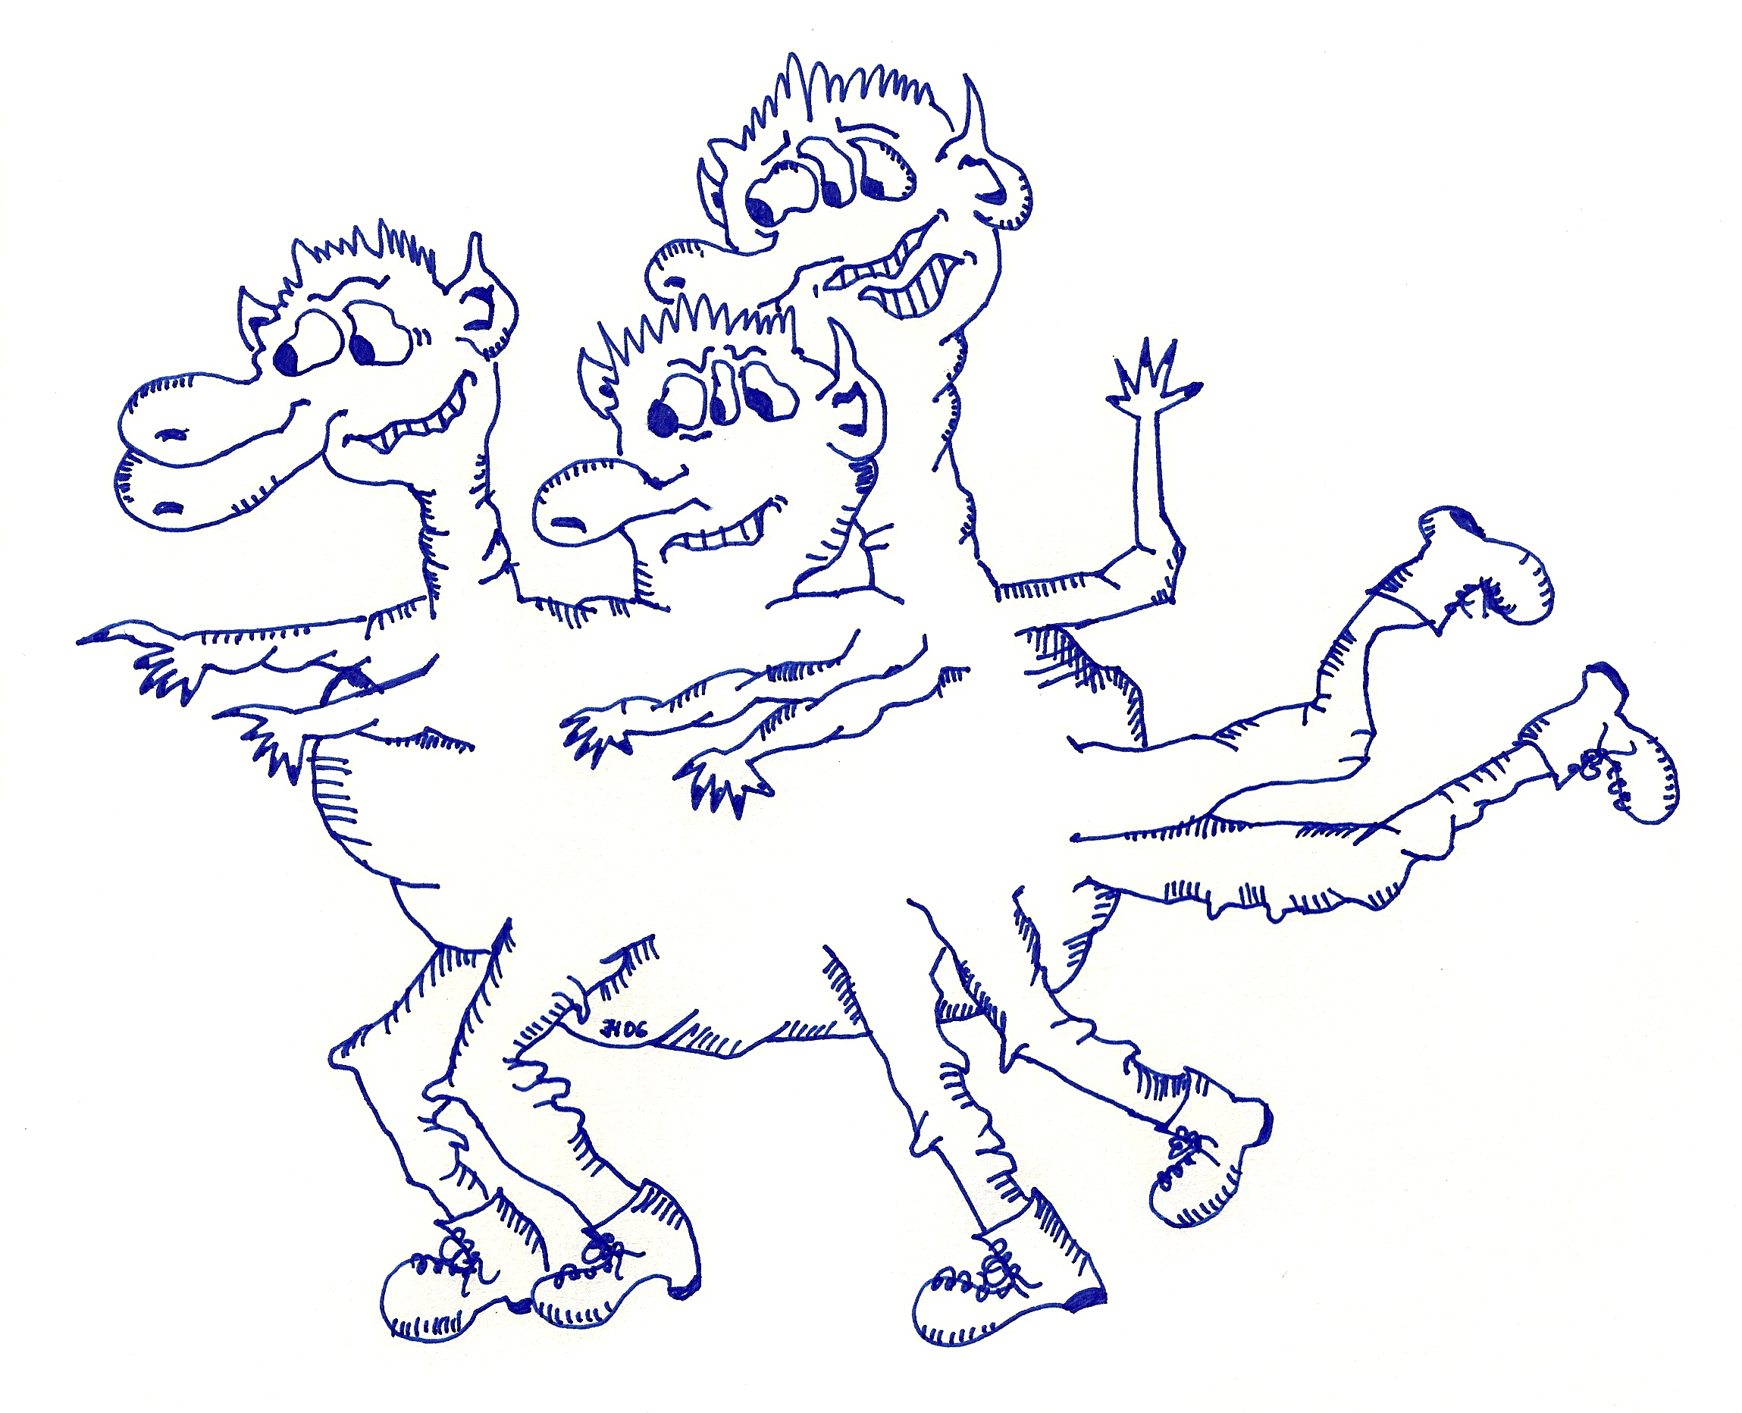
My funny monster

Doplň otázky či zkrácené odpovědi tak, aby bylo vše pravdivé podle obrázku:

1. _________________________ arms? No, it hasn´t.
2. _________________________ eyes? Yes, it has.
3. Has it got five noses? ____________________________________
4. Has it got three heads? ____________________________________
5. _________________________ necks? Yes, it has.
6. __________________________ ears? Yes, it has.
7. ________________________ mouths? Yes, it has.
8. Has it got ten legs? ____________________________________
9. Has it got four necks? ____________________________________
10. Has it got eleven eyes? ____________________________________
11. Has it got long hair? ____________________________________
12. _________________________ legs? Yes, it has.
13. Has it got eight ears? ____________________________________
14. Has it got five arms? ____________________________________
15. _______________________ heads? No, it hasn´t.

