KONTROLNÍ PRÁCE KPPE3INTROTOU1PO2009

Jméno: _______________________ Třída: _________ Datum: _________________ Body: ________ Známka: _________

1. Doplňte věty pomocí výrazů v závorkách. Použijte vždy přítomný čas průběhový nebo prostý.

1. „Where´s Tom?“ „___________________________________ (he / have) a shower.“
2. ___________________________________ (I / not / watch) television very often.
3. Listen! Claire ___________________________________ (sing)!
4. „Excuse me but ___________________________________ (you / sit) in my place.“ „Oh, I´m sorry.“
5. What time ___________________________________ (your father / finish) work in the evenings?
6. Sue ___________________________________ (not / like) coffee.
She ___________________________________ (she / prefer) tea.
7. Martin ___________________________________ (not / drive) to work now.
8. „Hi, Lisa! Who ___________________________________ (you / wait) for?“
„____________________________________ (I / wait) for you.“
9. How often ___________________________________ (you / read) a newspaper?
10. „Oh, dear! It´s late! What ___________________________________ (Jack / cook)?“
„___________________________________ (he / cook) dinner for him.“

2. Přelož otázky a napiš ke každé zkrácenou odpověď.
1. Byli zubaři nudní?
_____________________________________________________________________ No, _______________________
2. Byl tento popový koncert vzrušující?
_____________________________________________________________________ Yes, _______________________
3. Byl včera Petr v kuchyni?
_____________________________________________________________________ Yes, _______________________
4. Byl jsi soukromý detektiv?
_____________________________________________________________________ No, _______________________
5. Byli její rodiče nemocní?
_____________________________________________________________________ Yes, _______________________
6. Bylo to moře studené?
_____________________________________________________________________ No, _______________________
7. Byla Jessica vdaná?
_____________________________________________________________________ Yes, _______________________
8. Byl jeho prsten neobvyklý?
_____________________________________________________________________ No, _______________________
9. Byli tvoji prarodiče slavní?
_____________________________________________________________________ No, _______________________
3. Napište anglicky dvojice vět o Jennifer. Činnosti označené ✗ Jennifer včera neudělala, činnosti označené ✓ Jennifer včera provedla. Např.: Jennifer neuvařila oběd. Ona šla do obchodu.

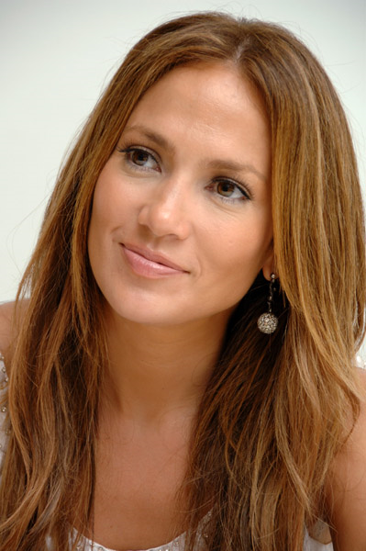 | 1. | ✗ | choose new shoes | ✓ | choose a new skirt
 | 2. | ✗ | break a bottle of milk | ✓ | break a bottle of juice
 | 3. | ✗ | buy meat | ✓ | buy some vegetables
 | 4. | ✗ | meet her friends | ✓ | meet her cousins
 | 5. | ✗ | wear jeans | ✓ | wear a dress
 | 6. | ✗ | be at work | ✓ | be at home
 | 7. | ✗ | eat sandwiches for lunch | ✓ | eat some chips for lunch
 | 8. | ✗ | send a letter to a friend | ✓ | send a postcard to his granny
 | 9. | ✗ | sleep in bed | ✓ | sleep on the sofa
Jennifer Lopez | 10. | ✗ | sell any books | ✓ | sell some magazines

1. ________________________________________________________________________________________________
________________________________________________________________________________________________
2. ________________________________________________________________________________________________
________________________________________________________________________________________________
3. ________________________________________________________________________________________________
________________________________________________________________________________________________
4. ________________________________________________________________________________________________
________________________________________________________________________________________________
5. ________________________________________________________________________________________________
________________________________________________________________________________________________
6. ________________________________________________________________________________________________
________________________________________________________________________________________________
7. ________________________________________________________________________________________________
________________________________________________________________________________________________
8. ________________________________________________________________________________________________
________________________________________________________________________________________________
9. ________________________________________________________________________________________________
________________________________________________________________________________________________
10. ________________________________________________________________________________________________
________________________________________________________________________________________________

4. Napište anglicky názvy členů rodiny.

1. | zeť |  | 9. | tchán
2. | syn |  | 10. | synovec
3. | švagrová |  | 11. | snacha
4. | teta |  | 12. | manžel
5. | tchýně |  | 13. | vnuk
6. | manželka |  | 14. | dcera
7. | vnučka |  | 15. | švagr
8. | neteř |  | 16. | sestřenice

5. Poskládejte věty ze slov a napište je ( ... bacha, jsou to věty tázací...).

1. | back | did | come | when | they | ?

___________________________________________________________________________________________________

2. | Italy | family | did | to | move | why | your | ?

___________________________________________________________________________________________________

3. | did | up | where | her | grow | uncle | ?

___________________________________________________________________________________________________

4. | the | she | week | gardener | did | find | last | ?

___________________________________________________________________________________________________

6. Napište anglicky pouze minulé časy uvedených sloves ( ... a bacha, některá jsou pravidelná, některá nepravidelná...).

1. | řídit |  | 9. | stát
2. | zmizet |  | 10. | žehlit
3. | potopit |  | 11. | vzít
4. | dát |  | 12. | probudit
5. | (roz)řešit |  | 13. | zůstat
6. | házet |  | 14. | zatknout
7. | (s)balit |  | 15. | schovat
8. | krmit |  | 16. | létat

.... bacha, na poslední straně je ještě BONUS !! ⇨⇨⇨
☺☺☺☺☺ BONUS ☺☺☺☺☺ BONUS ☺☺☺☺☺ NEPOVINNÉ CVIČENÍ ☺☺☺☺☺ BONUS ☺☺☺☺☺ BONUS ☺☺☺☺☺

Přečtěte si článek a poté rozhodněte, zda níže uvedené věty jsou pravdivé (připiš P) či nepravdivé (připiš N).

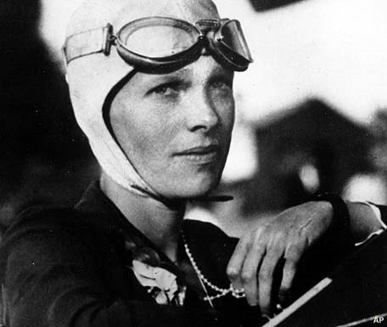
AMELIA MARY EARHART (1897 – 1937)

The first woman to fly across the Atlantic

Amelia was born in her grandparents‘ house in Kansas. Her parents didn´t have any money, but her grandparents were rich and sent her to the best schools. At the age of twenty she decided to study nursing and worked in a hospital in World War I. When she was 23, she visited an airshow and went up in a plane. At that moment, she knew that she wanted to be a pilot.
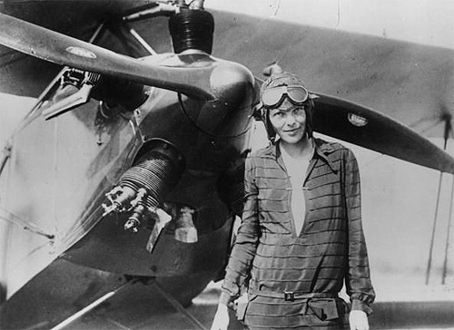
In 1920 flying was dangerous and people didn´t think it was the activity for women. But Amelia had flying lessons, and a year later, she broke her first record – she flew up to 14,000 feet. She married at 34, but never had children. The next year she became the first woman (and the second person) to fly alone across the Atlantic. She was now famous, and she travelled around the world to talk about her experiences. And in 1935, when she was 38, she became the first person to fly alone across the Pacific.
When she was nearly 40, Amelia wanted to be the first woman to fly around the world. She began the 29,000 mile flight in Miami on 1st June 1937. On 2nd July she was nearly at the end of her journey, when she and her plane disappeared near Howland Island in the Pacific Ocean.
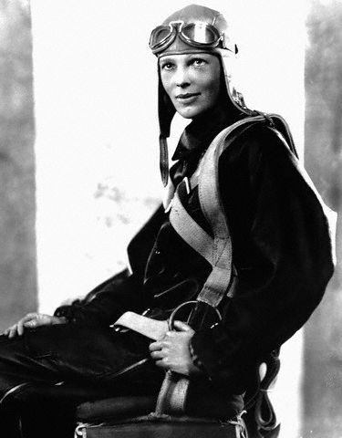
__________ Amelia came from a rich family.
__________ She had a short but exciting life.
__________ She fought in a World War.
__________ She wanted to be a pilot when she was a child.
__________ She broke her first record in 1920.
__________ She was the first person to fly alone across the Pacific.
__________ She flew fighter jets.
__________ She was married, but didn´t have any children.
__________ She travelled to Europe to talk about her experiences.
__________ She died in the Pacific.

Minislovníček:

decide = rozhodnout se flight = let nurse = zdravotní sestra
experience = zkušenost, zážitek jet = proudová stíhačka journey = cesta

