Kontrolní práce PO20116BPE2U1 | Name: | Points: | Grade:

1. Napište anglicky data běžným způsobem (např. 6th May).

1.6. |  | 11.5.
5.8. |  | 2.11.
13.2. |  | 26.9.
22.10. |  | 12.2.
10.11. |  | 15.6.
23.3. |  | 21.9.
31.12. |  | 30.7.
9.4. |  | 3.1.

2. Napište dvojice vět podle vzoru. Činnosti označené ✗ nejsou vykonávány, činnosti označené ✓ jsou vykonávány.
Př. Birds don´t fly to America. They fly to Africa.

Př. | Birds | ✗ | fly to America | ✓ | fly to Africa
1. | William | ✗ | sit on the chair | ✓ | sit on the sofa
2. | My uncle | ✗ | ride a bike | ✓ | ride a horse
3. | Jim, Tom and Peter | ✗ | live in Brno | ✓ | live in Moscow
4. | Little children | ✗ | eat meat | ✓ | eat vegetables
5. | His friend | ✗ | go to work | ✓ | walk in the park

1. _______________________________________________________________________________________________
_______________________________________________________________________________________________
2. _______________________________________________________________________________________________
_______________________________________________________________________________________________
3. _______________________________________________________________________________________________
_______________________________________________________________________________________________
4. _______________________________________________________________________________________________
_______________________________________________________________________________________________
5. _______________________________________________________________________________________________
_______________________________________________________________________________________________

3. Přeložte věty s příslovci.

1. Ona nikdy nevynáší odpadky. __________________________________________________________________________________
2. Oni vždy venčí psa. __________________________________________________________________________________
3. My často myjeme nádobí. __________________________________________________________________________________
4. On obvykle čistí auto. __________________________________________________________________________________
5. Tom někdy vysává podlahu. __________________________________________________________________________________
6. Mary nežehlí často prádlo. __________________________________________________________________________________

4. Utvořte tázací věty ze zadaných výrazů (přítomný čas prostý).

1. Julie / play / piano? _____________________________________________________________________________
2. Tom / use / computer / for his homework? __________________________________________________________
3. What / Mary / do / on Thursdays after school? _______________________________________________________
4. Where / you / usually / go / at the weekend? ________________________________________________________
5. When / the students / have / lunch / at school? ______________________________________________________
6. Bob and Mike / play / tennis? _____________________________________________________________________
5. Přečtěte si text a rozhodněte, zda věty níže jsou pravdivé (P) nebo nepravdivé (N).

Mr White
David White is our Geography teacher. He likes his job very much, but his wife, Mary doesn´t like her job. She´s a Maths teacher in our school. She doesn´t like her job because the students don´t usually like her subject. Sometimes they don´t like Geography either, but I think it´s very interesting. We do a lot of interesting things in the class.
Mr and Mrs white´s daughter, Zoe, is in my class. She says that her dad helps at home. He sometimes does the shopping and takes the rubbish out and he always feeds the dog. He often cooks dinner, too. Zoe usually washes up, and vacuums the floor. Mr White never washes the car because his son Andy does it. Andy is at our school, too.
Mary teaches Zoe and Andy Maths and they both like it. Andy doesn´t do Geography, he does French instead.

1. The Geography teacher doesn´t like his job. _____ 6. Zoe normally washes up. _____
2. The Maths teacher´s name is Mary White. _____ 7. Andy always cleans the car. _____
3. A lot of students like Maths. _____ 8. Zoe doesn´t like Maths. _____
4. All the students think Geography is interesting. _____ 9. David and Mary are Zoe´s teachers. _____
5. Zoe sometimes feeds the dog. _____ 10. Andy learns French. _____

6. Odpovězte podle obrázků na otázku: What are the people and the animals doing now? (Přítomný. č. průběhový)

 | 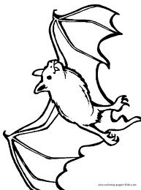 | 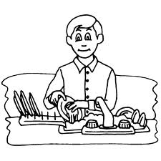 | 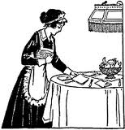 | 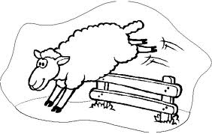 | 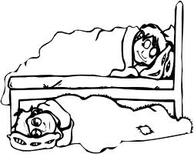 | 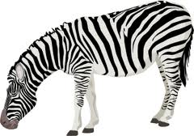
Elizabeth | The bat | Tom | Mum | The sheep | Jack and Ben | The zebra
 | 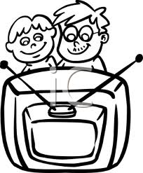 | 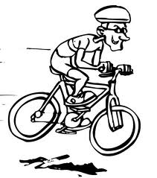 |  | 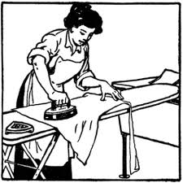 | 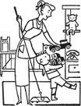 | 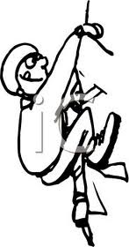
The crocodile | Children | Jacob | The lion | Jessica | Mum and Sam | Fred

1. ___________________________________________ 8. ___________________________________________
2. ___________________________________________ 9. ___________________________________________
3. ___________________________________________ 10. ___________________________________________
4. ___________________________________________ 11. ___________________________________________
5. ___________________________________________ 12. ___________________________________________
6. ___________________________________________ 13. ___________________________________________
7. ___________________________________________ 14. ___________________________________________

